Spelling Policy

- Principles

Spelling is important in ensuring children are independent, accurate, confident writers.
At Belleville, spelling:
- is taught explicitly and regularly (including time to consolidate and strengthen prior learning)
- is differentiated
- Is taught using a range of strategies
- is assessed regularly

- Practice:

Spelling is taught explicitly and regularly in all year groups through:
- Skills lessons in Y1-6
- Phonics lessons in EYFS
- Words to learn being sent home weekly
- Links with handwriting

Spelling is differentiated through:
- Matching work according to phonic stage, spelling difficulty, range of words, vocabulary, level of application, investigation, pattern finding and explanation
- Giving children regular opportunities to practise words which are personal to them
- Giving some children additional time to consolidate and strengthen prior learning from previous year group/earlier stage of year

Spelling is taught using a range of strategies**
- Identify and count phonemes represented by sound buttons and dashes and later identifiying syllables
- Use phonics charts to find suitable representations of sounds
- Identify/highlight tricky words and the tricky parts of words
- Use pattern and analogy to link known words/patterns
- Find words within words
- Make links with other words they know
- Create images in words and/or pictures
- Over-articulate and emphasise how the tricky parts of words are said; say it how it looks.
- Use and create their own mnemonics
- Use prefixes and/or suffixes and understand how they transform word meaning
- Use spellings in a sentence context (e.g homophones)
- Identify their own mis-spelt/tricky words and try to rewrite them in several different ways – what looks right?
- Consider word meanings and etymology
- Practise letter strings that often go together (linked to handwriting)
- Repeat writing of words to learn (eg rainbow write, trace write, quick-write, look cover write check, eyes closed write)

Spelling is assessed regularly and used to inform future teaching. Assessment of spelling is through:
- Dictation sentences using cloze procedure (weekly in books Y1-6)
- Word list tests (when additional support or assessment is needed)
- Use of individual whiteboards for quick write-and show activities
- Application and outcomes of specific spelling tasks in lessons
- Application of patterns and rules in independent writing
- Identification of appropriate words to correct/practise from independent writing

Teachers will:
- Follow the Programme of Study for phonics (Nursery to Y2)
- Follow the Programme of Study for spelling* (Y1 to Y6)
- Follow the Transcription lesson plans to teach spelling rules and patterns
- Respond to spelling work in line with the Feedback Policy
- Identify spelling errors which children will practise (in all subjects – as per feedback policy)
- Give appropriate lists of words to learn to be taken home weekly
- Model use of and emphasise spelling strategies in shared writing
- Teach the full range of strategies (**see above) for how to learn spellings
- Display spellings and prompts to assist independence in writing
- Plan and use dictation as weekly assessment tool to inform progress and future teaching
- Ensure children who have spelling difficulties are supported
- Teach children how to check own spellings and expect them to do so
- Give time for children to proof read and check for spelling errors
- Teach how to use dictionaries and spell checkers (Y2-6)

Children will:
- Appreciate the importance of accuracy in spelling
- Use phonics to segment sounds and syllables and refer to phonics charts
- Take responsibility for checking own spellings as appropriate to age
- Respond to feedback about spelling
- Apply rules and words to learn independently
- Use range of strategies and resources to aid accuracy and independence
- Learn the words given
- Find best ways for themselves to learn and remember spellings

Related policies and resources:
- Writing Policy
- Feedback Policy
- Phonics Policy
- Programme of Study for Phonics (Nursery to Year 2)
- Programme of study for Spelling (Year 3 to Year 6)
- Transcription lesson plans (Years 1-6)
- National Curriculum objectives and spelling Appendix 1

NOTE: *The programmes of study cover all the statutory National Curriculum content and strategies

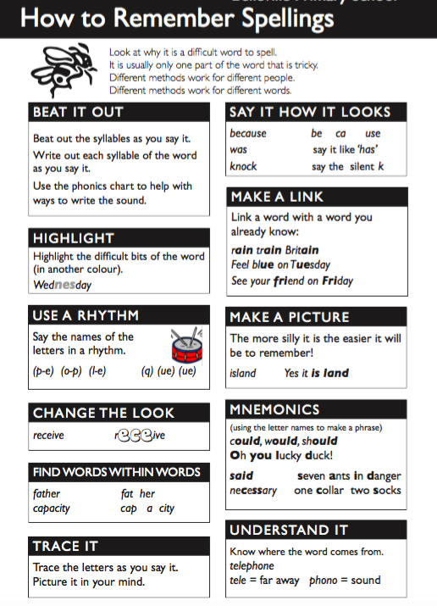

Spelling Grid
Rainbow writing:
My spellings to practise:

Pyramid Writing:

Look, say, cover, write, check:

Sound button the word/identify tricky parts:
Draw around the word:
Write the meaning of the word:
Write the word in a sentence:

