Sport Premium funding for the 2021-2022 academic year

Funding summary
The amount of PE and Sport Premium the school received for 2021-22 | £23,200
Amount carried over from 2020-21 (due to covid-19 pandemic and associated school closures) | £25,958
Total available | £49,158
INTENT: Our approach to PE, sport and physical activity
Physical education is very much part of the school’s ethos and vision, with well-established and talented specialist teachers leading an engaging, ambitious, relevant and nurturing PE curriculum. We recognise whole-school benefits in pupils’ engagement, behaviour and mental health, as well as parental attitudes and engagement with the school. Our aim is to ensure ALL pupils leave primary school physically literate and with the knowledge, skills and motivation necessary to equip them for a healthy, active lifestyle and lifelong participation in physical activity and sport.
We guide children to discover the relationship between physical activity and good health. Alongside developing fundamental movement skills, we place our pupils' social and emotional development at the heart of our curriculum.
We have a whole-school drive to develop a greater variety of physical activities throughout the school day, and to increase participation from specific groups, in particular those entitled to pupil premium, those with SEND, and ‘reluctant engagers’.
We will continue to use the funding to develop PE, physical activity and sport at Belleville. We will also use the funding to build capacity and capability within our school to ensure that improvements made now are sustainable and will benefit pupils joining the school in future years.
The engagement of all pupils in regular physical activity – Chief Medical Officer guidelines recommend that:
1. Primary school pupils undertake at least 30 minutes of physical activity a day in school
2. The profile of PE, school sport and physical activity being raised across the school as a tool for whole school improvement
3. Increased confidence, knowledge and skills of all staff in teaching PE and sport
4. Broader experience of a range of sports and activities offered to all pupils.

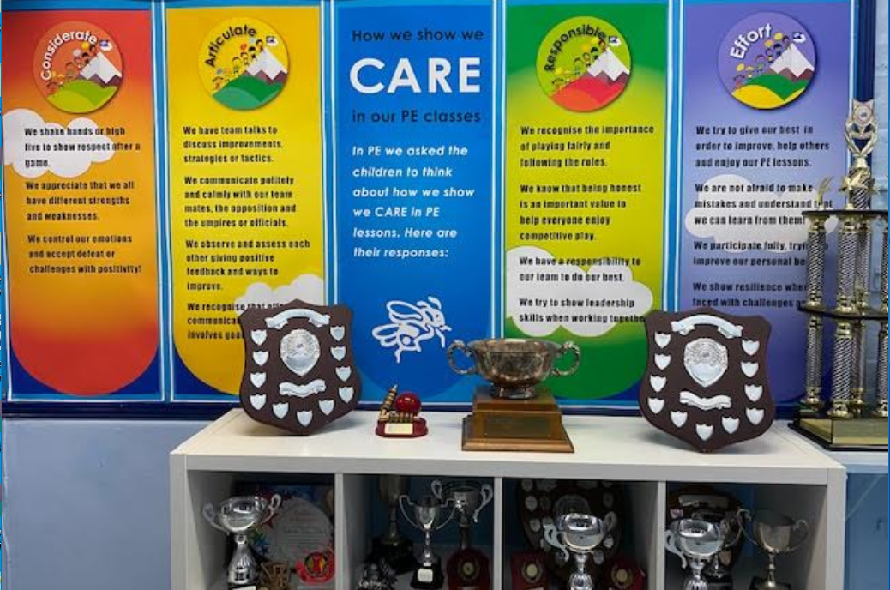

IMPLEMENTATION: How we will use our PE Premium funding in 2021-22
Key indicator 1: The engagement of all pupils in regular physical activity
- Increase participation in local sports tournaments, fixtures and festivals (including inclusive sports event) through membership of and liaising with the local sports partnership (Wandsworth School Games).
- Extend the school clubs offer in order for children currently receiving pupil premium funding to be invited and access free clubs using given funding.
- Increase participation in festivals and more inclusive tournaments.
- Engage children in more active play – through lunchtimes and skipping workshops with all years.
- Purchase PE and lunchtime play equipment resources to ensure that children have the resources to stay active during their play times and experience a range of sports/activities.

Key indicator 2: The profile of PE, sport and physical activity being raised as a tool for school improvement
- Develop our school website, communications and displays to promote PE/sports, encourage increased participation and boost parent engagement.
- Invest in specialist sports coaches to lead a variety of extra-curricular sports clubs in school and within curriculum time.

Key indicator 3: Increased confidence, knowledge and skills of all staff in teaching PE and sport
- Through specific training increase confidence, expertise, knowledge and skills of the PE staff in teaching physical education.
- Professional development to increase knowledge and skills of staff - CPD opportunities through Wandsworth Sports.
- Train Teaching Assistants and Sports Leaders from Year 5/6 to lead active and fun games during play and lunchtimes.

Key indicator 4: Broader experience of a range of sports and activities offered to all pupils
- Invest in specialist sports coaches to lead a variety of extra-curricular sports clubs in school.
- Engage children in more active play – through lunchtimes and skipping workshops with all years.
- Engage in different competitions – Boccia, Festivals etc.
- Provide a range of sports within extra-curricular sports clubs eg: badminton, judo.
- Purchase PE and lunchtime play equipment resources to ensure that children have the resources to stay active during their play times and experience a range of sports/activities.
- Provide top-up swimming lessons and clinics for children who fail to reach swimming outcomes as well as swimming clinics for children on pupil premium register.

Key indicator 5: Increased participation in competitive sport
- Increase participation in local sports tournaments, fixtures and festivals (including inclusive sports event) through membership of and liaising with the local sports partnership (Wandsworth School Games).

